Colossians 4 Prayer and Leadership

What kinds of things do we typically pray for in a summary prayer at the end of church or Sunday school or other Christian meeting?

2 Devote yourselves to prayer, being watchful and thankful.

Can you think of other verses that talk about being thankful as part of prayer?
__________________ __________________ _______________

3 And pray for us, too, that God may open a door for our message, so that we may proclaim the mystery of Christ, for which I am in chains. 4 Pray that I may proclaim it clearly, as I should.

Where is Paul?
What is his primary prayer request?

5 Be wise in the way you act toward outsiders; make the most of every opportunity.

Why would Paul say this?
Do we think this is really the case?
How do our actions show this? Should they?

6 Let your conversation be always full of grace, seasoned with salt, so that you may know how to answer everyone.

What does salt do? Why would Paul have said that?
Salt can __________________
Salt can __________________
Salt can __________________

Final Greetings
7 Tychicus will tell you all the news about me. He is a dear brother, a faithful minister and fellow servant in the Lord. 8 I am sending him to you for the express purpose that you may know about our circumstances and that he may encourage your hearts. 9 He is coming with Onesimus, our faithful and dear brother, who is one of you. They will tell you everything that is happening here.

Why not just send a letter? What is special about people delivering a message?

People in these final sections:
Tychicus: Acts 20:4; Ephesians 6:21; Colossians 4:7; 2 Timothy 4:12; Titus 3:12
Onesimus: see the book of Philemon
Aristarchus: Acts 19:29, 20:4, 27:2; Colossians 4:10; Philemon 1:24
Mark: many times – probably the one that wrote Peter’s story
Epaphras: Also in Philemon
Luke sends greetings – it is not known his connection to Colossae
Demas – another interesting one! Colossians 4:14 and Philemon 1:24, 2 Timothy 4:10
Archippus: in Philemon

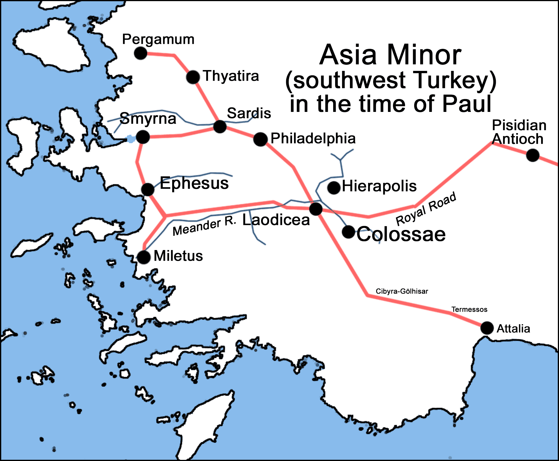
10 My fellow prisoner Aristarchus sends you his greetings, as does Mark, the cousin of Barnabas. (You have received instructions about him; if he comes to you, welcome him.) 11 Jesus, who is called Justus, also sends greetings. These are the only Jews among my fellow workers for the kingdom of God, and they have proved a comfort to me. 12 Epaphras, who is one of you and a servant of Christ Jesus, sends greetings. He is always wrestling in prayer for you, that you may stand firm in all the will of God, mature and fully assured. 13 I vouch for him that he is working hard for you and for those at Laodicea and Hierapolis. 14 Our dear friend Luke, the doctor, and Demas send greetings. 15 Give my greetings to the brothers at Laodicea, and to Nympha and the church in her house.

Many denominations use Paul’s admonition that ladies should not lead men any time anywhere. Interestingly though he sends specific greetings to this early church leader.
It is one Biblical lady, along with Pricila and Lydia that Nazarenes quote to justify female church leaders. (By the way, the entire Texas District was started by ladies.)
Are there other Biblical examples of ladies leading men with God’s blessing?
Here are a few more:

- Deborah (Judges 4-5):
- Esther (Book of Esther):
- Huldah (2 Kings 22, 2 Chronicles 34):
- Priscilla (Acts 18):
- Abigail (1 Samuel 25):
- Wise Woman of Abel Beth-Maacah (2 Samuel 20):
- Miriam (Exodus 15):

New Testament Leadership Roles
- Phoebe (Romans 16:1):
- Junia (Romans 16:7):
- Chloe (1 Corinthians 1:11):

16 After this letter has been read to you, see that it is also read in the church of the Laodiceans and that you in turn read the letter from Laodicea.

This is common, and probably why we have this letter today. People probably wanted to keep it, so they copied it before sending it on to Laodicea. That would be hand-copied! Do we do spiritual work equally difficult in our lives? What do we get excited to keep and treasure – is it things of God? Like what?

17 Tell Archippus: “See to it that you complete the work you have received in the Lord.”
18 I, Paul, write this greeting in my own hand. Remember my chains. Grace be with you.

Paul writes a lot of things about prayer and requests prayer.
Interestingly, guess what he does NOT ask prayer for.
What can we learn from reading this passage that we can carry with us into this week?

